Active Directory Home Lab Setup and Configuration
Setup & Configuration Lab Report
Windows Server 2019 • Domain: cyberlab_aj.local • Hands-On Lab

Author | AJAJ AHMED
Domain Name | cyberlab_aj.local
OS Platform | Windows Server 2016 (DC01) + Windows 10 Client01 (WIN10aj) + Windows 10 Client02 (WINaj2)
IP Scheme | 192.168.10.0 / 24 | DC: 192.168.10.1 | Client: 192.168.10.10 | 192.168.10.12
Technologies | AD DS, DNS, DHCP, Group Policy, Remote Server Administration Tools
Lab Type | VirtualBox / VMware Virtualized Isolated Environment
Date | 2025

This report documents the full end-to-end process of deploying Active Directory Domain Services on Windows Server 2019, promoting the server to a Domain Controller, joining a Windows 10 client to the domain, and managing users, groups, and permissions. All steps include annotated screenshots.

1. Introduction & Lab Overview
This report will explain how to set up and configure an Active Directory Domain Services (AD DS) infrastructure with Windows Server 2019 and Windows 10 client machines in a virtualized lab environment. The project illustrates the steps involved in installing and configuring a Domain Controller, DNS, Organizational Units (OUs), users, groups and adding client systems to the domain.

The primary goal of this lab was to have hands-on experience with Windows Server administration and Active Directory management in a simulated enterprise network. The practical usage of domain administration, user management, authentication, networking and system configuration skills that are commonly used by System Administrators and Cybersecurity professionals.

Lab Objectives
- Install Windows Server 2019 and configure a static IP address
- Promote the server to a Domain Controller with a new forest
- Configure DNS to point to the loopback address (127.0.0.1)
- Install the AD DS role via the Add Roles and Features Wizard
- Run the Active Directory Domain Services Configuration Wizard
- Join a Windows 10 workstation to the domain (cyberlab_aj.local)
- Create Organizational Units (OUs), Users, and Groups in Active Directory
- Assign users to groups and verify domain membership
Network Architecture
Server Hostname | DC01
Server IP | 192.168.10.1
Subnet Mask | 255.255.255.0
Preferred DNS | 127.0.0.1 (self)
Client Hostname | WIN10aj | WIN10aj2
Client IP | 192.168.10.10 |192.168.10.12 (or DHCP)
Domain | cyberlab_aj.local
Forest / Domain Functional Level | Windows Server 2019

2. Step 1 — Windows Server 2016 Initial Setup
2.1 Customize Settings — Administrator Account
After installing Windows Server 2016, the system prompts you to set a strong password for the built-in Administrator account. This account is the initial local admin used before Active Directory is configured.
- Set a complex password (minimum 8 characters, uppercase, lowercase, number, symbol)
- Click Finish to complete the initial setup phase
2.2 Server Manager Dashboard
Server Manager launches automatically on login and is the central hub for managing roles, features, and server health. Used this console to add the AD DS role in the next steps.
- Verify that the server appears under "Local Server" in the left navigation
- Note the current state: only File and Storage Services are installed
- Click "Add roles and features" to begin role installation
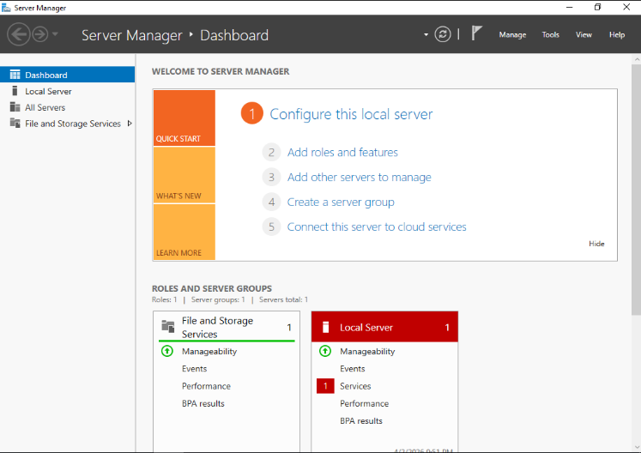
Fig 1. Server Manager Dashboard — before AD DS role installation

3. Step 2 — Configure a Static IP Address
Active Directory requires a static IP address because DNS records must reliably resolve to the Domain Controller. If DHCP changes the DC's IP, clients may fail to authenticate.
3.1 Open Network Connections
Navigate to: Control Panel → Network and Internet → Network Connections.
We will see the Ethernet adapter (Ethernet0) listed as an Unidentified network.
3.2 Open Ethernet Properties → IPv4
Right-click Ethernet0 → Properties → Internet Protocol Version 4 (TCP/IPv4) → Properties.
The default setting is "Obtain an IP address automatically."
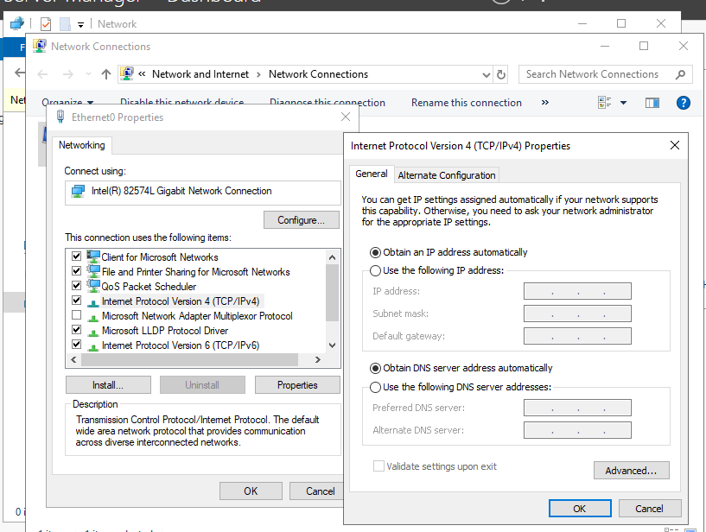
Fig 2. Ethernet Properties showing TCP/IPv4 — set to automatic by default
3.3 Set Static IP & DNS
Select "Use the following IP address" and enter the values below. Critically, set the Preferred DNS server to 127.0.0.1 (the server itself). This is required because AD DS uses DNS internally; the DC must resolve its own domain.
IP Address | 192.168.10.1
Subnet Mask | 255.255.255.0
Default Gateway | (leave blank or set to router)
Preferred DNS Server | 127.0.0.1

Why 127.0.0.1 for DNS? When AD DS is installed, it sets up a DNS zone for cyberlab_aj.local on this server. The DC must query itself for that zone. Using 127.0.0.1 ensures the DC always finds its own DNS service, even before network connectivity is verified.

4. Step 3 — Add the AD DS Role
4.1 Add Roles and Features Wizard — Before You Begin
In Server Manager, click "Add roles and features." The wizard opens with the "Before You Begin" page confirming prerequisites: strong admin password, static IP, and Windows Update is current.
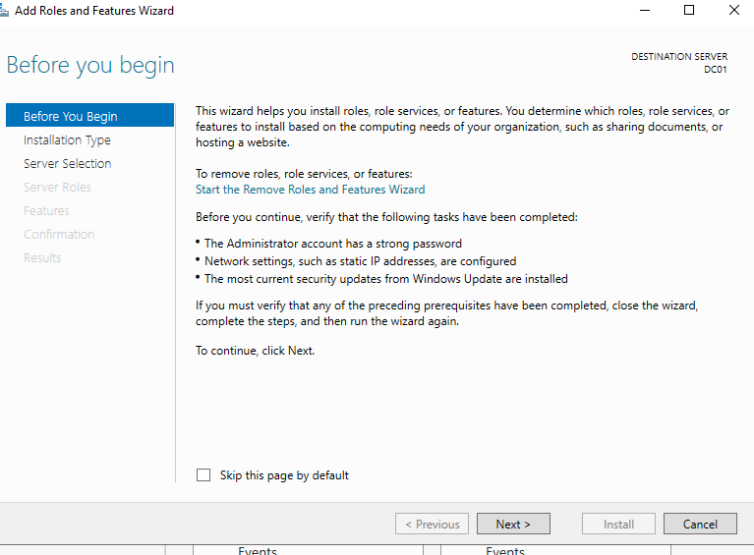
Fig 3. Add Roles and Features Wizard — Before You Begin page
4.2 Installation Type
Select Role-based or feature-based installation. This installs roles directly on the physical or virtual server (as opposed to Virtual Desktop Infrastructure scenarios).
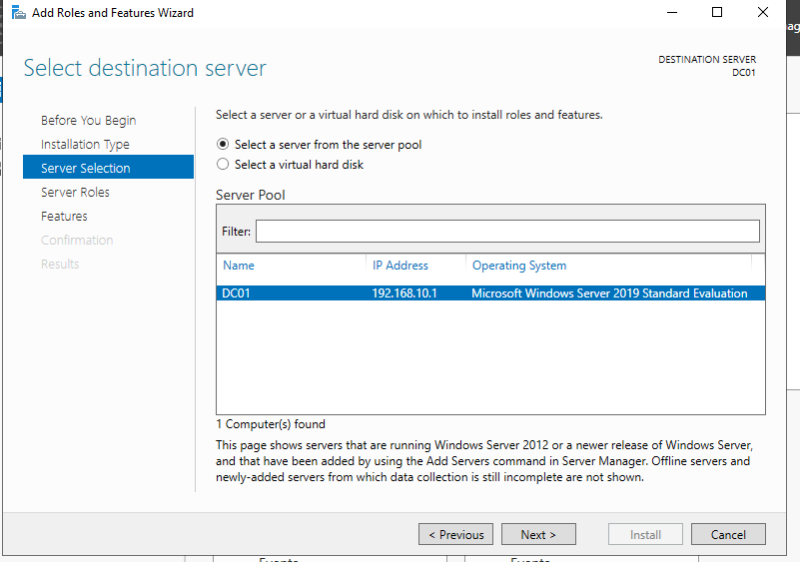
Fig 4. Wizard — Installation Type: Role-based or feature-based installation
4.3 Server Selection
The wizard detects the local server (DC01 at 192.168.10.1). Confirm it is selected from the server pool and click Next.
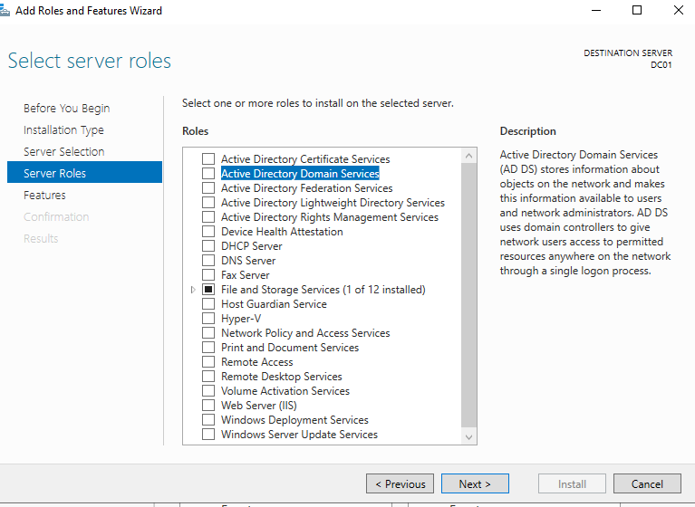
Fig 5. Server Selection — DC01 selected from the server pool
4.4 Select Server Roles — AD DS
In the Roles list, check "Active Directory Domain Services." A popup appears listing additional required features and management tools.
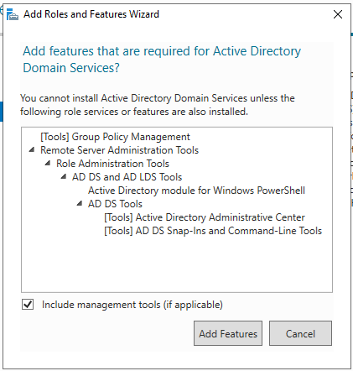
Fig 6. Server Roles — Active Directory Domain Services selected
4.5 Add Required Features
Click "Add Features" in the popup. The wizard automatically selects: Group Policy Management, Remote Server Administration Tools (RSAT), AD DS and AD LDS Tools, Active Directory Administrative Center, and AD DS Snap-Ins.
4.6 Features Page
No additional features are required beyond what was auto selected. Click Next.
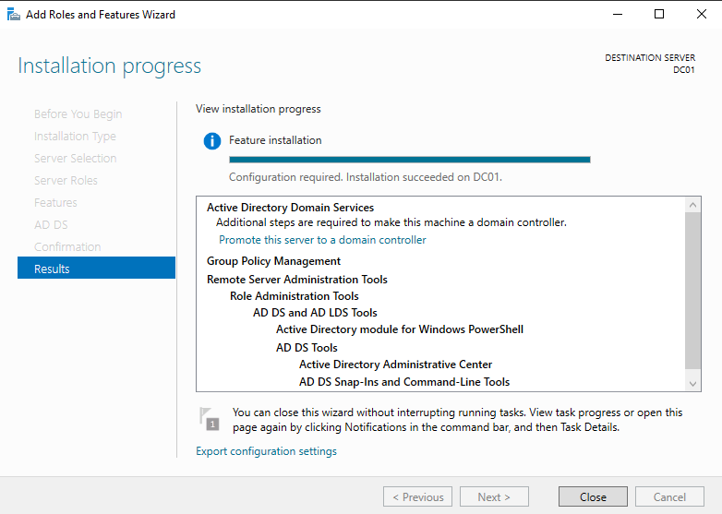
Fig 7. Features page — defaults accepted
4.7 AD DS Information Page
The wizard displays important information about AD DS: the role uses domain controllers to store directory data and manage user authentication. Read the notes about DNS integration and site topology.
4.8 Confirmation — Install AD DS
Review the selections: Active Directory Domain Services and its associated management tools. Click Install. The installation proceeds in the background. Do not close Server Manager.
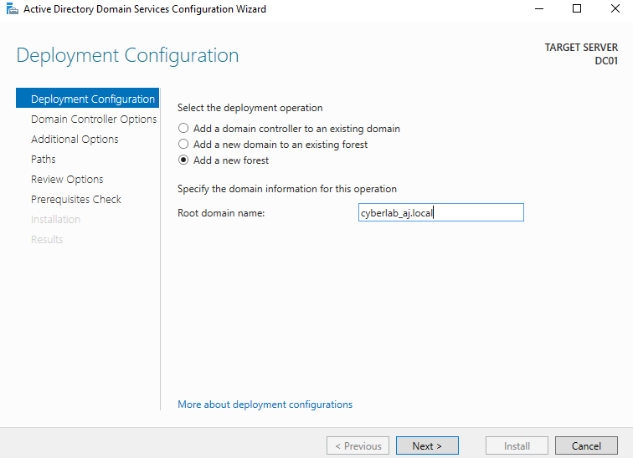
Fig 8. Confirmation page — ready to install AD DS role
4.9 Installation Progress
The progress bar advances as Windows installs roles and features. This typically takes 2–5 minutes. A notification will appear in Server Manager when finished.
4.10 Installation Complete — Promote to DC
Once installation finishes, a yellow warning flag appears in Server Manager: "Configuration required. Promote this server to a domain controller." Click this link to launch the AD DS Configuration Wizard.
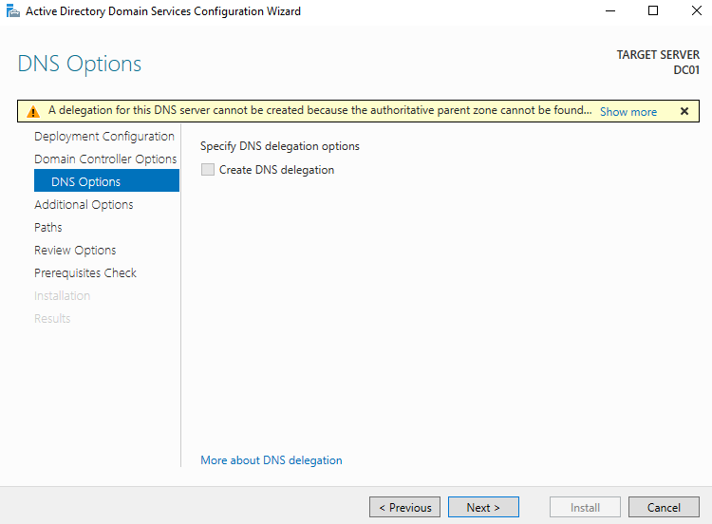
Fig 9. Post-install notification — Promote this server to a domain controller

5. Step 4 — Promote Server to Domain Controller
5.1 Deployment Configuration — Add New Forest
In the AD DS Configuration Wizard, select "Add a new forest." Enter the root domain name: cyberlab_aj.local. This creates a brand-new Active Directory forest and domain.
Deployment Operation | Add a new forest
Root Domain Name | cyberlab_aj.local
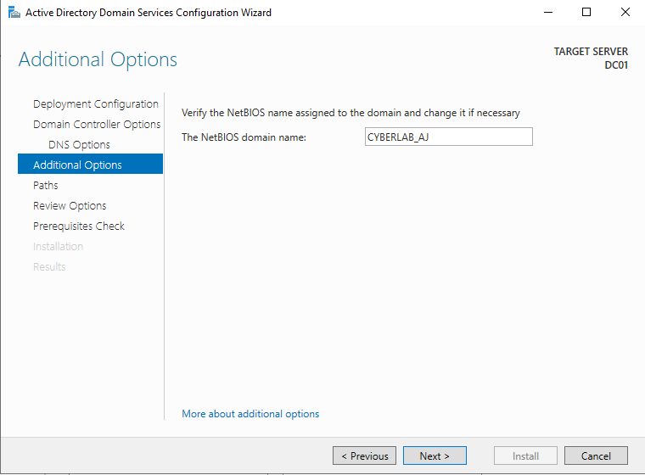
Fig 10. Deployment Configuration — Add a new forest, root domain: cyberlab_aj.local
5.2 Domain Controller Options
Set the Forest and Domain functional levels to Windows Server 2019. Leave DNS Server and Global Catalog checked. Set a Directory Services Restore Mode (DSRM) password — this is used to recover AD in emergency scenarios.
Forest Functional Level | Windows Server 2019
Domain Functional Level | Windows Server 2019
DNS Server | Checked (recommended)
Global Catalog (GC) | Checked (required for first DC)
Read-Only DC (RODC) | Unchecked
DSRM Password | (set a strong recovery password)

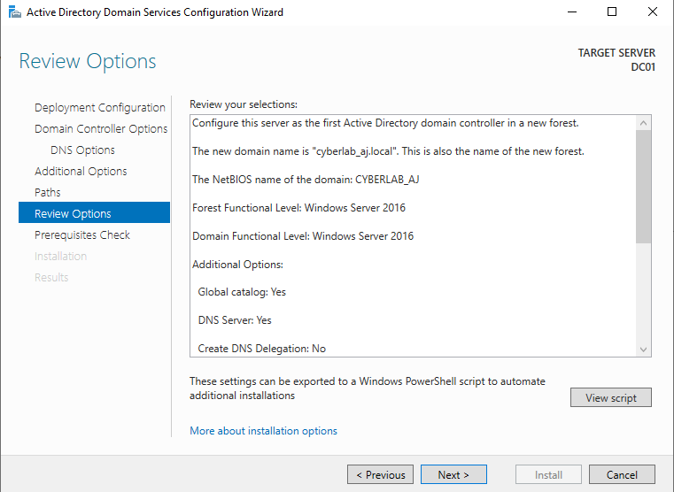
Fig 11. Domain Controller Options — functional levels, DNS, GC, and DSRM password
5.3 DNS Options
A warning about DNS delegation is normal for a new forest with no parent DNS zone. Ignore this warning and click Next. The wizard will configure DNS automatically.
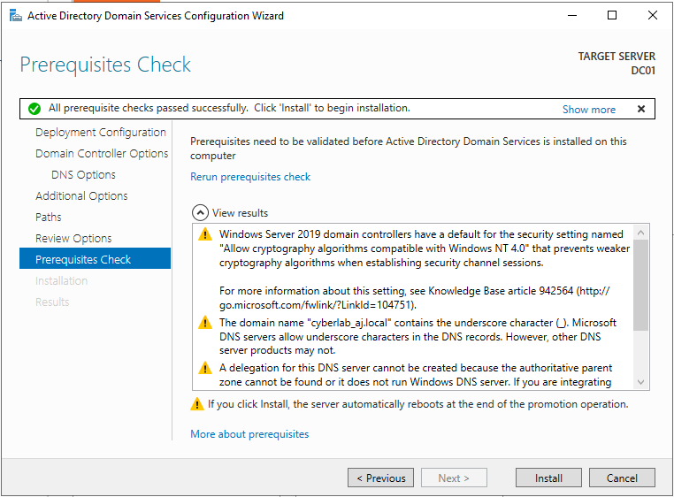
Fig 12. DNS Options — delegation warning (expected for new forest, safe to ignore)
5.4 Additional Options — NetBIOS Name
The wizard automatically derives the NetBIOS domain name from the domain label. It will be set to CYBERLAB_AJ (the part before. local, uppercased). This name is used for legacy compatibility.
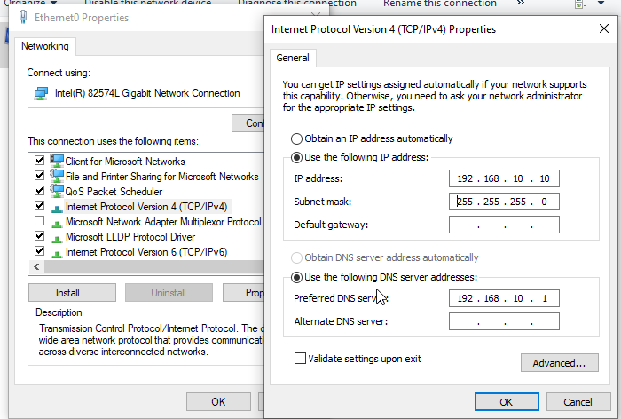
Fig 13. Additional Options — NetBIOS name auto-populated as CYBERLAB_AJ

5.5 Paths — Database, Log Files, SYSVOL
The default paths store AD DS data in C:\Windows\NTDS. In production environments, these are often moved to a dedicated disk for performance and recovery. For this lab, accept the defaults.
Database Folder | C:\Windows\NTDS
Log Files Folder | C:\Windows\NTDS
SYSVOL Folder | C:\Windows\SYSVOL

5.6 Review Options
The wizard displays a full summary of all selections. You can export this configuration as a Windows PowerShell script for future automation or documentation.
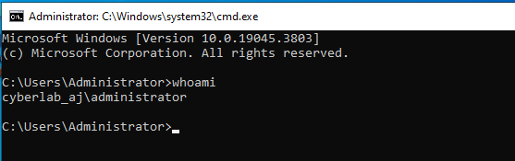
Fig 14. Review Options — summary of AD DS configuration
5.7 Prerequisites Check
The wizard runs a prerequisites check. Warnings about DNS delegation and Windows Firewall settings are expected and do not block installation. Look for the green "All prerequisite checks passed" message.
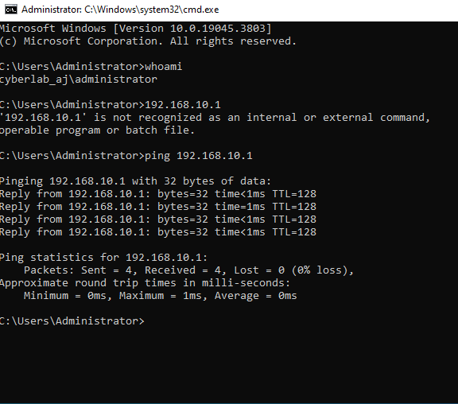
Fig 15. Prerequisites Check — all checks passed, ready to install
5.8 Installation & Reboot
Click Install. The server configures AD DS, DNS zones, and SYSVOL replication, then automatically reboots. After the reboot, the server will log in as CYBERLAB_AJ\Administrator — the domain administrator account.
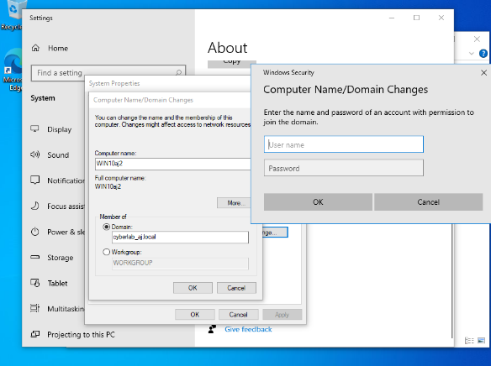
Fig 16. AD DS installation complete — server rebooting to apply domain configuration

6. Step 5 — Post-DC-Promotion Verification
6.1 Server Manager After Reboot
After the reboot, Server Manager now shows the AD DS and DNS roles installed. The server identity in the top navigation changes to reflect the domain. Navigate to Tools → Active Directory Users and Computers to verify the domain structure.
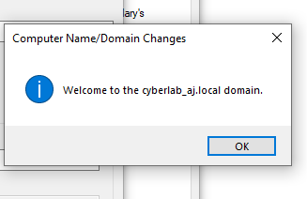
Fig 17. Server Manager post-promotion — AD DS and DNS roles visible
6.2 Active Directory Users and Computers (ADUC)
Open Tools → Active Directory Users and Computers.
The cyberlab_aj.local domain tree should appear in the left panel, showing the default containers: Built-in, Computers, Domain Controllers, ForeignSecurityPrincipals, and Users.
Fig 25. Active Directory Users and Computers — cyberlab_aj.local domain structure
6.3 Domain Controllers Container
Expand the "Domain Controllers" OU. DC01 should appear here as the first (and only) domain controller. This confirms successful promotion.
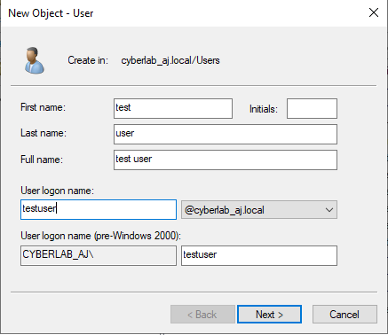
Fig 18. Domain Controllers OU — DC01 listed as the domain controller
7. Step 6 — Create Organizational Units, Users & Groups
7.1 Create an Organizational Unit (OU)
Organizational Units are containers within AD that allow you to organize resources and apply Group Policy.
Right-click cyberlab_aj.local → New → Organizational Unit.
- Name: Staff (or any logical grouping)
- Uncheck "Protect container from accidental deletion" for lab purposes
7.2 Create a New User
Right-click the Staff OU → New → User. Fill in the user details on the first page.
First Name | clark
Last Name | staff
Full Name | clark staff
User Logon Name | staffclark@cyberlab_aj.local
Password | (set a complex password)
Password never expires | Checked (lab setting)

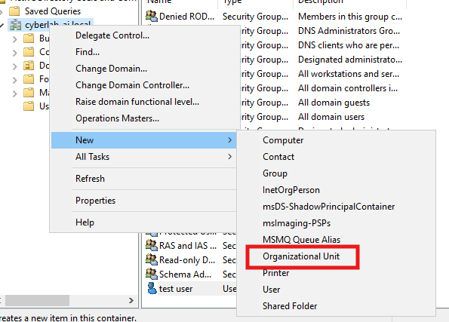
Fig 19. New User Wizard — entering first/last name and logon name
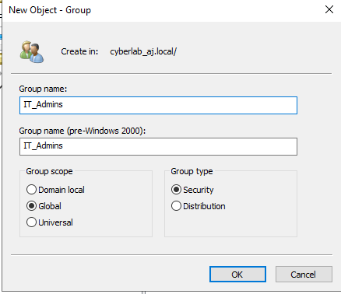
Fig 20. User password settings — password never expires selected for lab
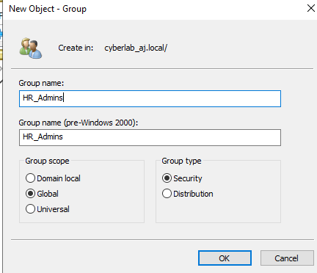
Fig 21. New user "clark staff" created in the Staff OU
7.3 Create a Security Group
Right-click the Staff OU → New → Group.
Security Groups are used to control access to shared resources and apply permissions collectively.
Group Name | staffclark (or a descriptive name)
Group Scope | Global
Group Type | Security
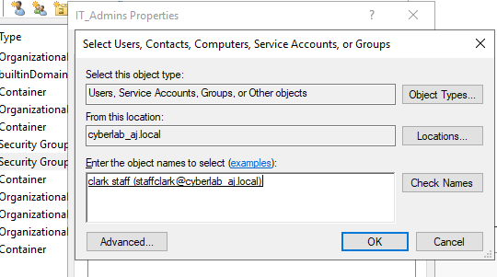
Fig 22. Creating a new Security Group in the Staff OU
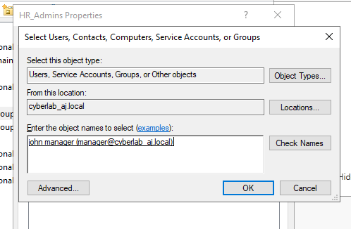
Fig 23. New Security Group created and visible in ADUC
7.4 Add User to Group
Right-click the Security Group → Properties → Members tab → Add. Search for the user (clark staff) and add them. This grants the user all permissions assigned to the group.
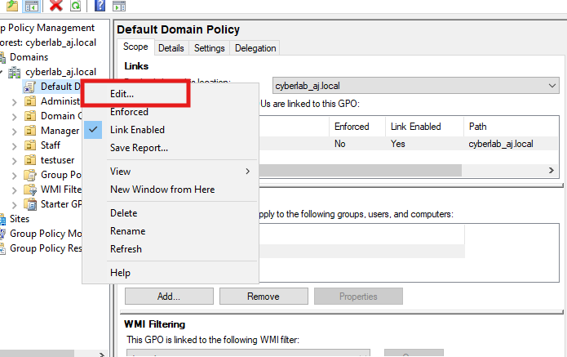
Fig 24. Adding user "clark staff" to the security group via ADUC
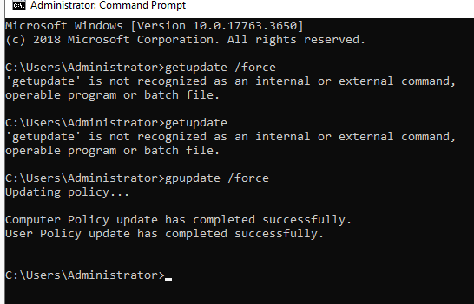
Fig 25. User successfully added as a member of the security group

8. Step 7 — Join Windows 10 Client to the Domain
8.1 Verify DC Connectivity from Client
On the Windows 10 machine (WIN10aj2), open Command Prompt and verify: (1) the logged-in user with whoami, (2) ping the DC at 192.168.10.1.
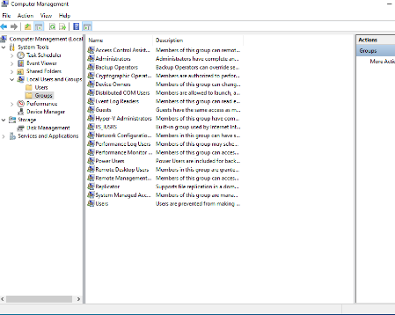
Fig 26. Command Prompt — whoami shows local machine, ping 192.168.10.1 successful (0% loss)
Before joining the domain, ensure the client PC's DNS server is set to the DC's IP address (192.168.10.1) in TCP/IPv4 settings. Without correct DNS, the domain name cyberlab_aj.local will not resolve.
8.2 Open System Properties — Change Domain
On WIN10aj2: Settings → System → About → Join a domain (or System Properties → Computer Name → Change).
In the "Member of" section, select Domain and type cyberlab_aj.local. A Windows Security dialog will prompt for domain credentials.
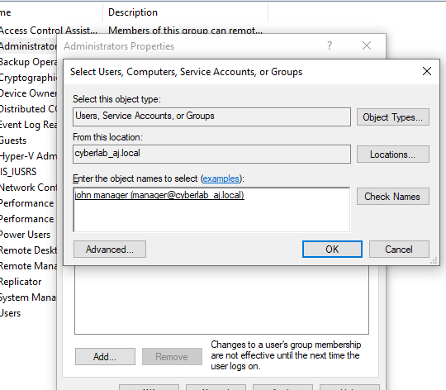
Fig 27. System Properties — entering cyberlab_aj.local as the domain to join
8.3 Provide Domain Admin Credentials
Enter the domain administrator credentials (CYBERLAB_AJ\Administrator). Windows contacts the DC via Kerberos/LDAP to authenticate and authorize the join. Click OK. A "Welcome to the cyberlab_aj.local domain" message confirms success. Restart the client.
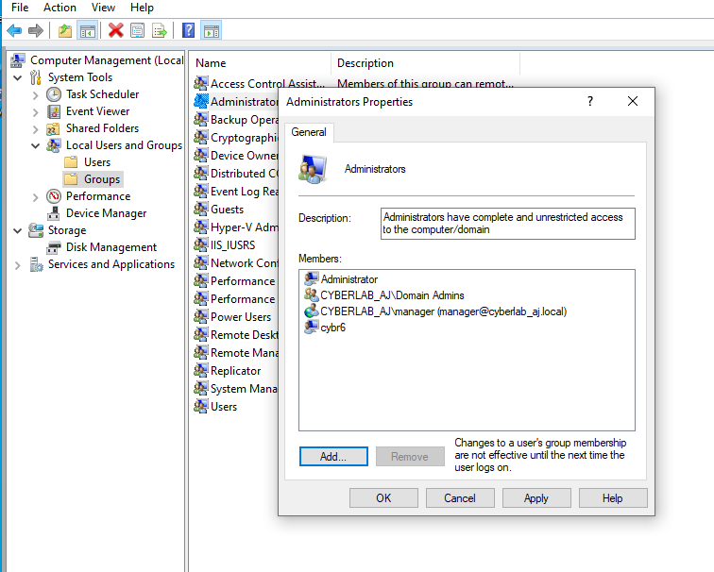
Fig 28. Domain joins successful — Windows Security authentication dialog and confirmation
8.4 Verify Client in ADUC
Back on the DC in Active Directory Users and Computers, expand the "Computers" container. WIN10aj2 should now appear as a computer object in the domain — confirming successful domain join.
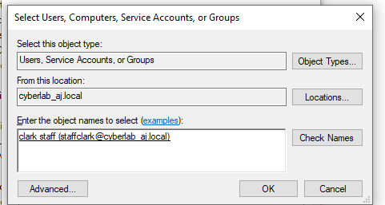
Fig 29. WIN10aj2 computer object visible in AD Computers container
8.5 Domain Login on Windows 10
On the Windows 10 machine, log out or restart. At the sign-in screen, choose "Other user" and log in with a domain account (e.g., cyberlab_aj\staffclark). A successful login confirms that domain authentication is working end-to-end.
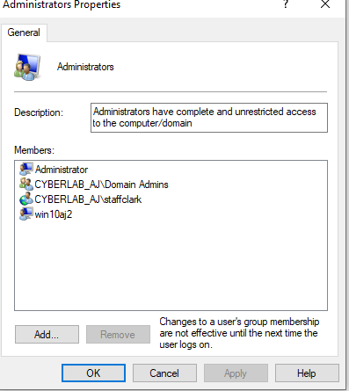
Fig 30. Windows 10 sign-in screen — logging in with domain credentials
9. Step 8 — Group Membership & Permissions Verification
9.1 View Group Members in ADUC
In ADUC,
Right-click the Security Group → Properties → Members.
Confirm that clark staff (staffclark@cyberlab_aj.local) is listed as a member.
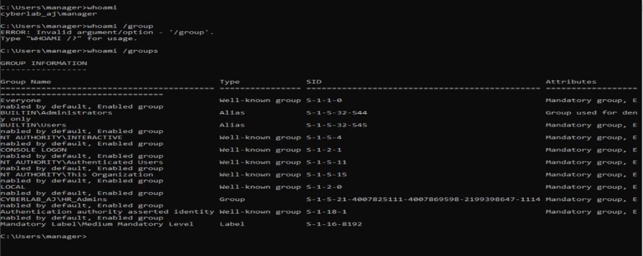
Fig 31. Security group Members tab — staffclark@cyberlab_aj.local listed
9.2 Verify Domain Admins Group
Navigate to ADUC → Builtin or Users → Administrators or Domain Admins.
View the members to confirm the group structure. In this lab, clark staff were added to the local Administrators group on WIN10aj2 for elevated access.
Administrators Group Members | Administrator, CYBERLAB_AJ\Domain Admins, CYBERLAB_AJ\staffclark, win10aj2 (computer)
Domain Admins Group | Administrator (default)
Domain User | staffclark — member of Staff OU security group

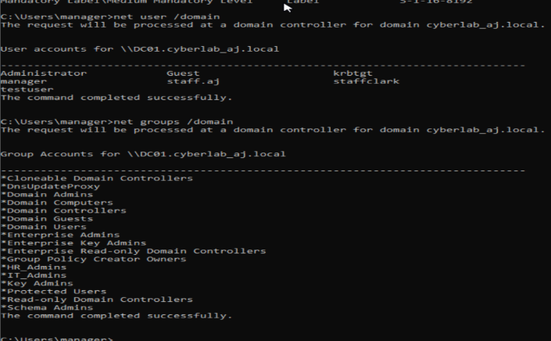
Fig 32. Administrators Properties — domain users and groups assigned
9.3 Final Group Summary
The final state of the Administrators group includes domain objects, confirming integration between the Windows 10 client and the Active Directory domain controller.
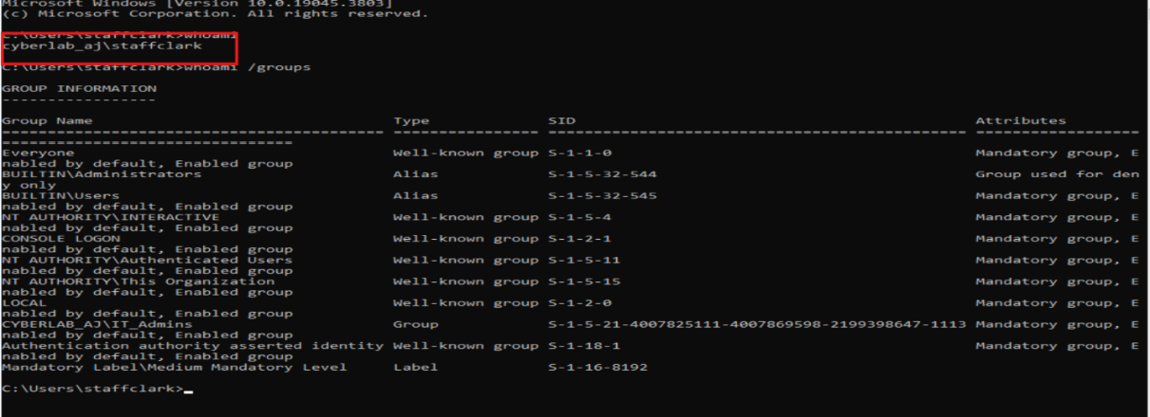
Fig 43. Final state — domain users added to the Administrators group on WIN10aj2

10. Summary & Key Concepts
What Was Accomplished
- Installed and configured Windows Server 2016 with a static IP and self-referential DNS
- Added the AD DS role using Server Manager's Add Roles and Features Wizard
- Promoted the server to a Domain Controller by creating a new forest (cyberlab_aj.local)
- Verified the domain structure in Active Directory Users and Computers
- Created an Organizational Unit (Staff), a user account (clark staff), and a Security Group
- Added the user to the security group for centralized permission management
- Joined a Windows 10 workstation to the domain and verified domain login
- Confirmed computer object registration in ADUC and group membership
Core Active Directory Concepts Demonstrated
AD DS | Centralized authentication and authorization directory service for Windows networks
Domain Controller | Server that authenticates users and enforces domain security policies
DNS Integration | AD DS uses DNS for service location (SRV records); DC must host its own DNS
SYSVOL | Shared folder on every DC holding Group Policy Objects and logon scripts
DSRM Password | Directory Services Restore Mode — used for AD recovery in safe mode
Global Catalog | Partial replicas of all objects in the forest; required for logon and search
Kerberos | Default authentication protocol for AD DS since Windows 2000
Organizational Unit | Container for organizing AD objects; target for Group Policy application
Security Group | Used to assign permissions to multiple users collectively
Computer Object | AD representation of a domain-joined machine; used for GPO targeting

Troubleshooting Tips
- Cannot join domain: Verify the client DNS points to the DC's IP (192.168.10.1), not 8.8.8.8
- Ping fails between DC and client: Check firewall settings on both machines and verify they are on the same subnet
- DSRM password forgotten: Boot into directory services restore mode and reset using ntdsutil
- Replication issues: Run "repadmin /showrepl" on the DC to check replication topology
- User cannot log in: Verify password policy, account lockout status, and group membership in ADUC
- DNS errors after promotion: Run "dcdiag /test:dns" for a comprehensive DNS health report
Relevant Commands Reference
whoami | Display current user context (local vs. domain)
ping <ip> | Test network connectivity to DC or client
ipconfig /all | Display full IP, DNS, and adapter configuration
nslookup cyberlab_aj.local | Test DNS resolution of domain name
net user /domain | List of all domain users from command line
gpupdate /force | Force Group Policy refresh on a client
dcdiag | Run domain controller diagnostic checks
repadmin /showrepl | Show AD replication status between DCs

End of Report — Active Directory Domain Services Lab
Domain: cyberlab_aj.local | #ActiveDirectory #WindowsServer #Homelab #SysAdmin

